WALLET App
Part 1: Install MetaMask & Set Up Wallet
Step 1: Install MetaMask
- Go to the official site: https://metamask.io/
- Click Download and choose your browser (Chrome, Firefox or Edge).
- Add the extension to your browser.
OR
- Open the App Store/Play Store
- Search for “MetaMask”
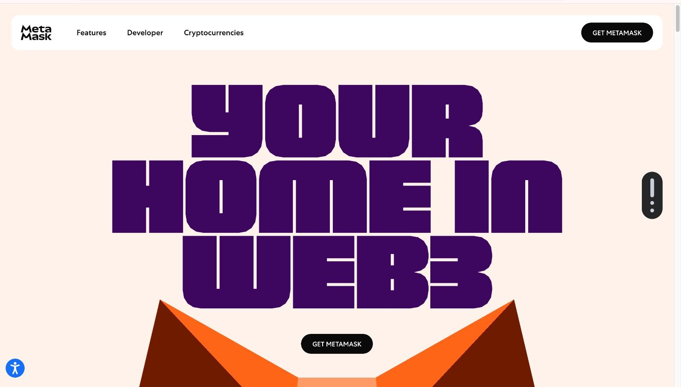
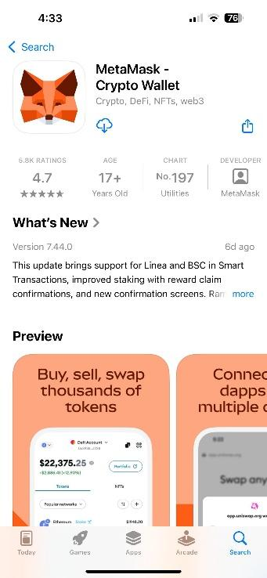
- Tap "Install" or "Get".
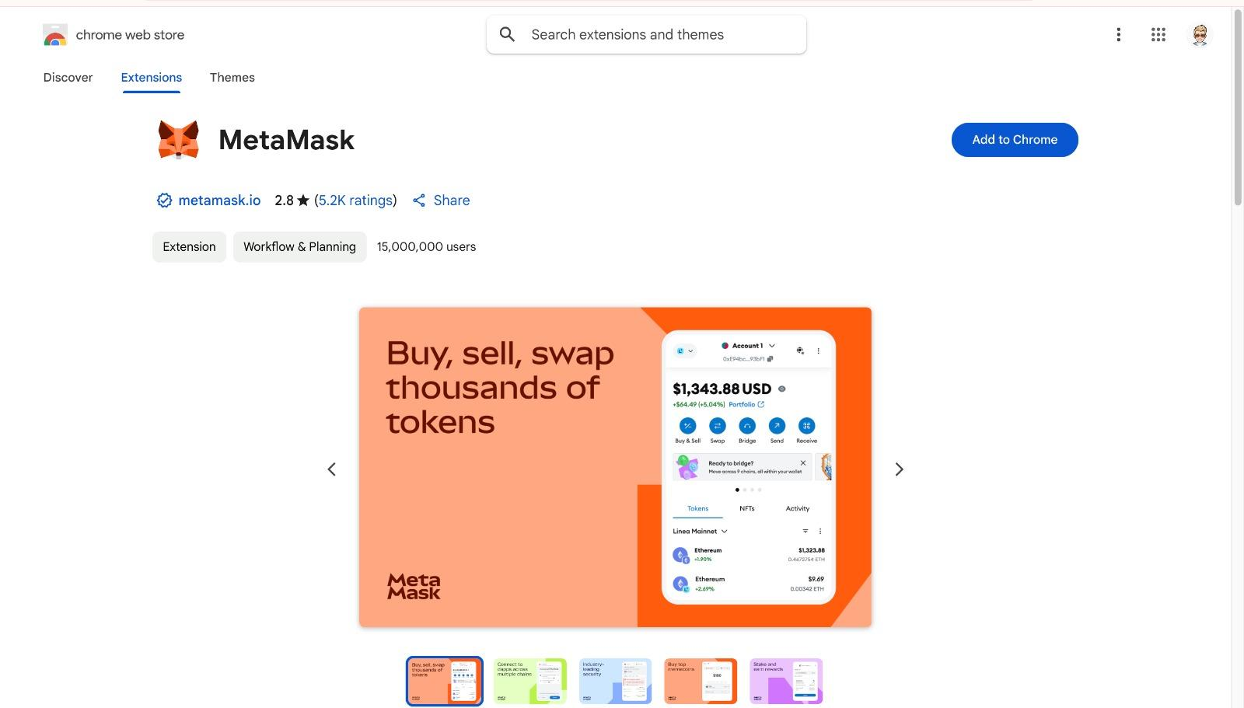
Step 2: Create or Import a Wallet
- Click the MetaMask extension icon.
- Choose Create a Wallet or Import Wallet (if you already have one).
- Follow the setup steps:
  - Set a password.
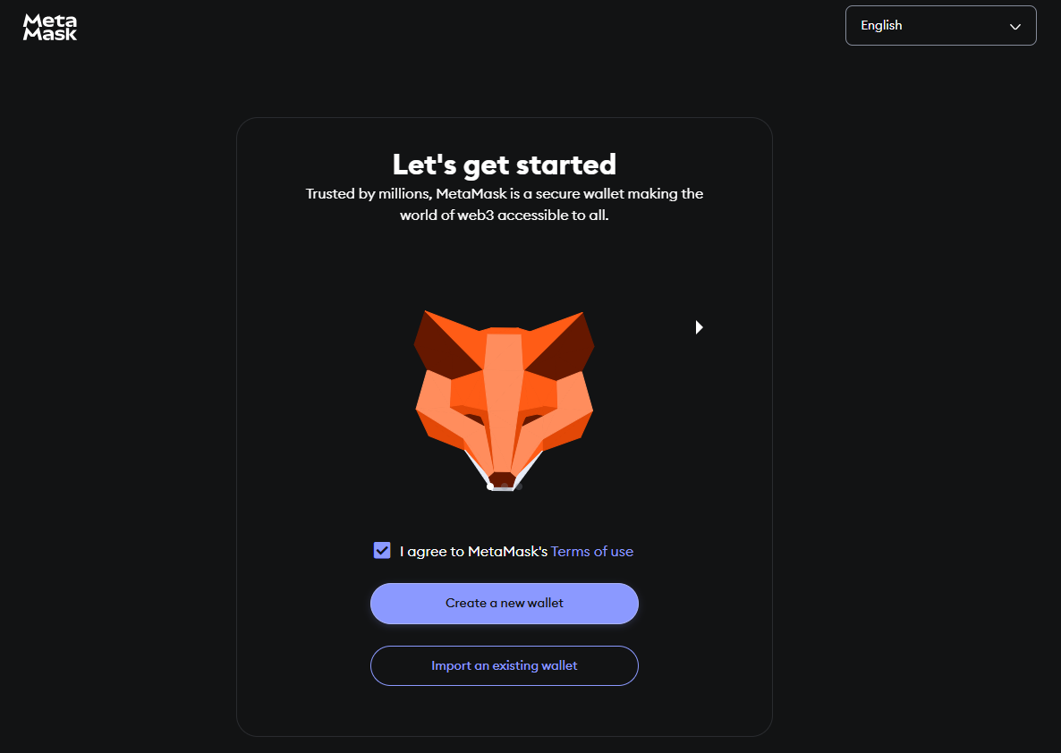
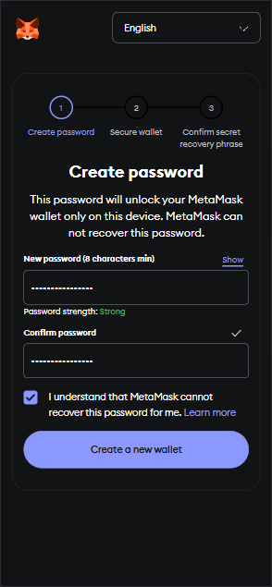
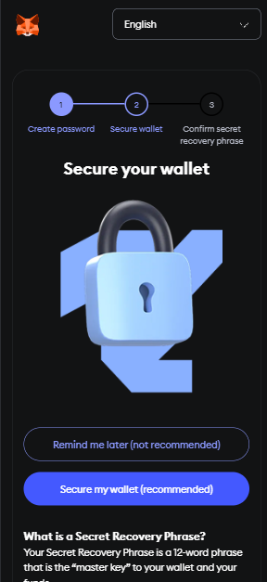
  - Back up your Secret Recovery Phrase securely.
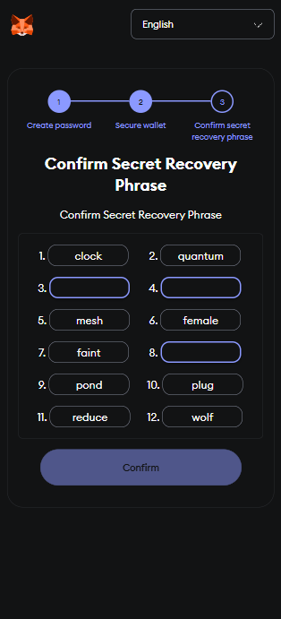
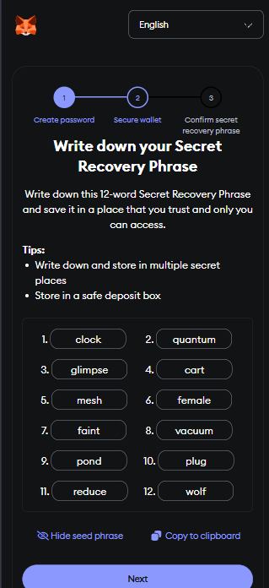

Step 3: Add a Test Network (Sepolia)
- Open MetaMask.
- Click your account icon > Settings > Networks.
- Add a network like Sepolia:
- Get free test ETH from a faucet:
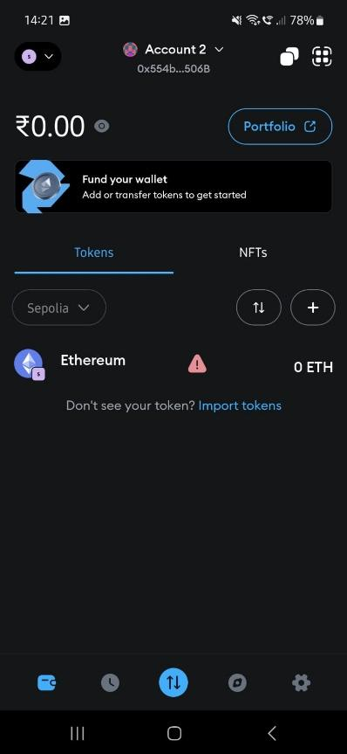
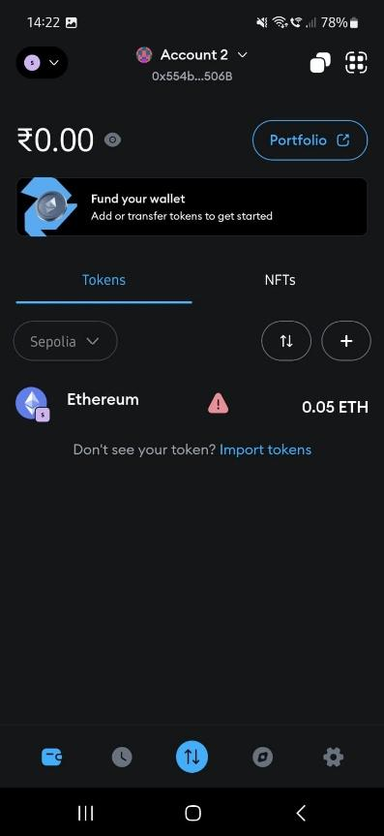
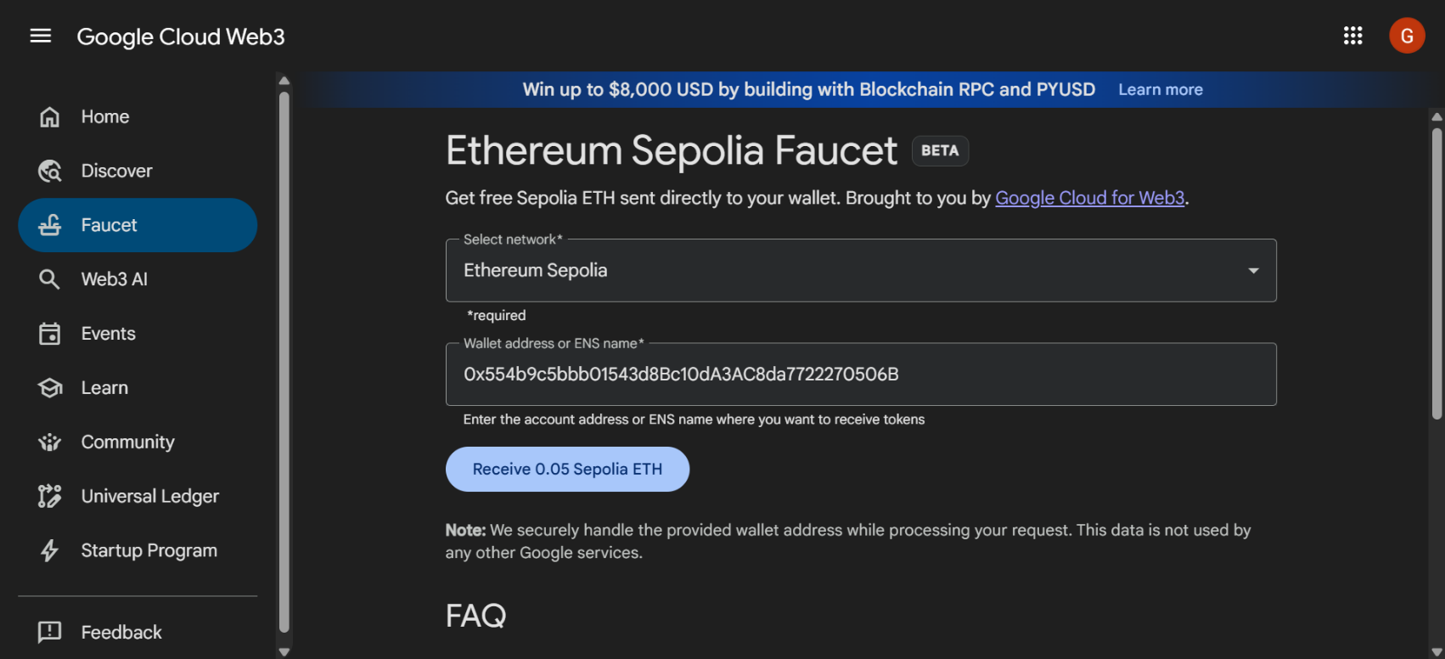
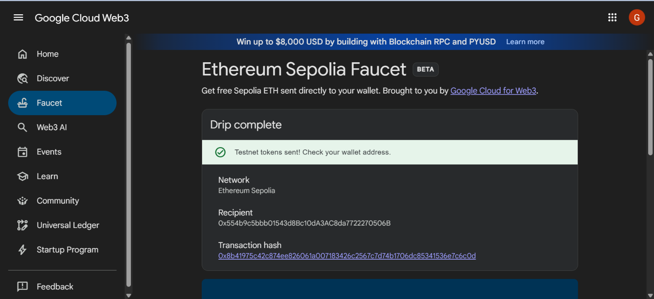
  - Sepolia Faucet: https://cloud.google.com/application/web3/faucet

Part 2: Smart Contract - Ether manager App
Step 4: Code for Smart Contract
// SPDX-License-Identifier: MIT
pragma solidity ^0.8.4;

contract EthWalletManager {
// Event emitted when a transfer occurs
event Transfer(
address indexed sender,
address indexed recipient,
uint256 amount,
uint256 timestamp
);

// Error messages
error InsufficientBalance(uint256 available, uint256 required);
error TransferFailed();
error ZeroAmount();
error ZeroAddressNotAllowed();

function getBalance() public view returns (uint256) {
return address(msg.sender).balance;
}

/**
* @dev Transfers ETH to a specified address
* @param recipient The address to send ETH to
* @param amount The amount of ETH to send in wei
*/
function transferEth(address payable recipient, uint256 amount) public payable {
// Input validation
if (recipient == address(0)) revert ZeroAddressNotAllowed();
if (amount == 0) revert ZeroAmount();

// Check sender's balance
if (address(msg.sender).balance < amount) {
revert InsufficientBalance({
available: address(msg.sender).balance,
required: amount
});
}

// Perform transfer
(bool success, ) = recipient.call{value: amount}("");
if (!success) revert TransferFailed();

// Emit event
emit Transfer(
msg.sender,
recipient,
amount,
block.timestamp
);
}

// Allow the contract to receive ETH
receive() external payable {}
}
Part 3: Deploy the Contract Using Remix
Step 5: Open Remix IDE
- Visit https://remix.ethereum.org
- Create a new file and paste in your EthWalletManager contract code.
Step 6: Compile the Contract
- Go to the Solidity Compiler tab.
- Make sure the version is set to ^0.8.4 or higher.
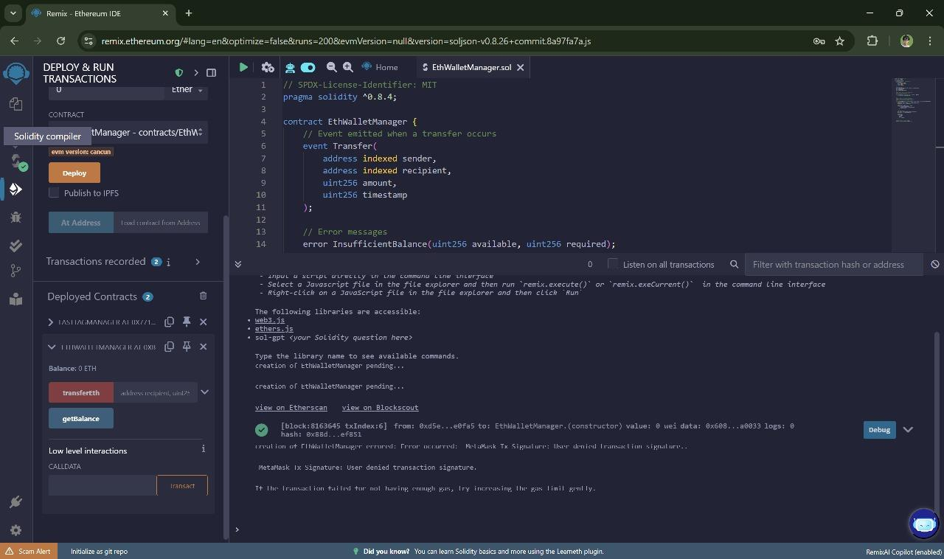
- Click Compile EthWalletManager.sol.

Step 7: Connect MetaMask to Remix
- Go to the Deploy & Run Transactions tab.
- In the Environment dropdown, choose Injected Provider - MetaMask.
- MetaMask will pop up — approve the connection to Remix.
Step 8: Deploy the Contract
- Make sure your account has some ETH (from faucet).
- Click Deploy.
- MetaMask will prompt you to confirm the transaction.
- Once deployed, your contract address will appear in Remix.
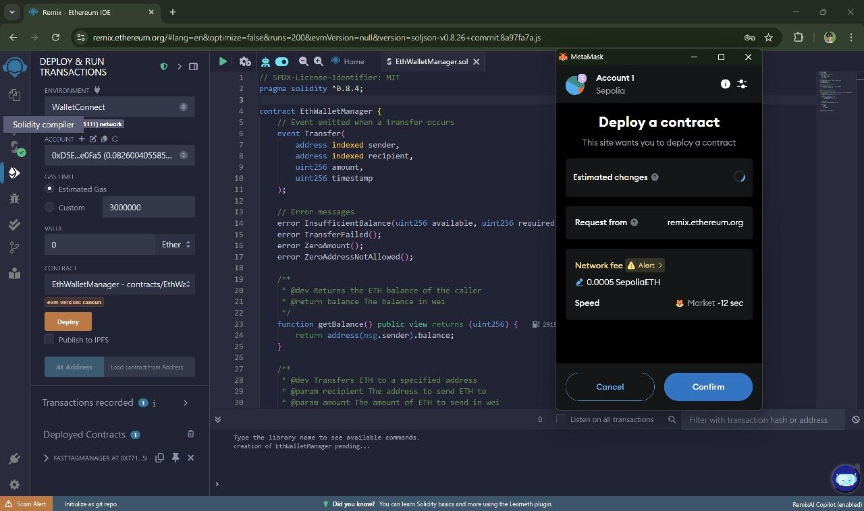
Part 4: Interact With the Smart Contract
Step 9: Use Remix Interface
- getBalance(): Calls your wallet’s ETH balance.
- Enter a recipient address.
- Set an amount in wei (1 ETH = 1e18 wei).
- Make sure your wallet has enough ETH to cover the transfer.
Step 10: Interact with the Contract from a Frontend (Flutter)
- Connect Your Wallet by Choosing MetaMask
- View Your Balance and Send or Receive ETH
- Optionally, tap “View Transactions” to see recent activity
